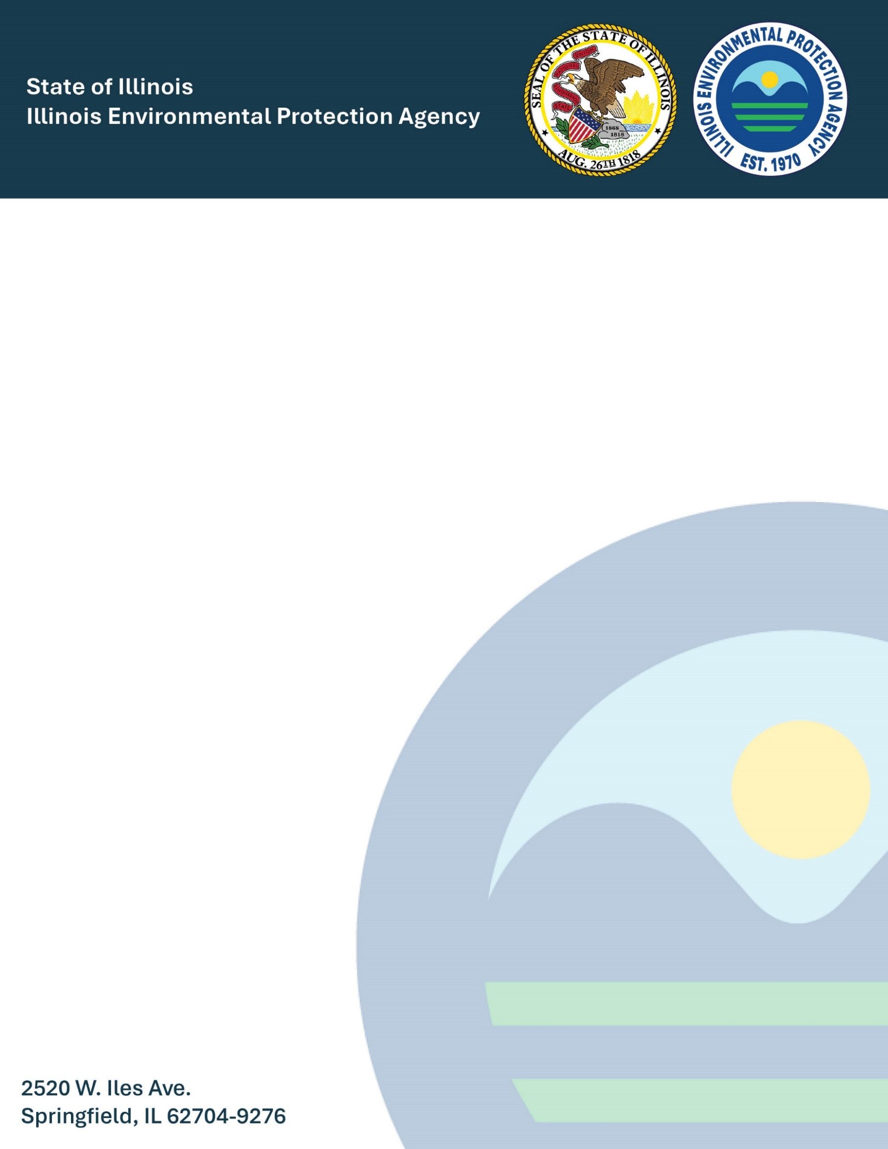
Monitoring for Lead in Schools and Child Care Facilities
October 2025

Monitoring for Lead in Schools and Child Care Facilities


  - Prepared By:

  - Illinois Environmental Protection Agency
  - Compliance Assurance Section
  - Division of Public Water Supplies
  - Bureau of Water
  - 2520 West Iles Avenue
  - Springfield, IL 62704

Contents
1. Introduction 2
1.1 Overview 415 ILCS 5/18; 35 Ill. Adm. Code 611.2362 2
1.2 Definitions 415 ILCS 5/18; 35 Ill. Adm. Code 611.2350(b) 2
2. Outreach 2
2.1 Public education to Schools and Child Care Facilities 415 ILCS 5/18; 35 Ill. Adm. Code 611.2362(a) 2
3. Sampling Locations and Methods 3
3.1 Sampling Locations 3
3.2 Sampling methods 4
4. Sampling Frequency 4
5. Alternative School and Child Care Lead Sampling Programs 5
6. Schools and Child Care Facilities Confirmation 6
7. Notice of Results 6
8. Lead Sampling in Schools and Child Care Facilities on Request 7
9. Reporting School and Child Care Facility Sampling and Lead Education 8
APPENDIX A 9
School and Childcare Facility Testing Timeline 9
APPENDIX B 11
Information About Health Risks from Lead in Drinking Water Template That Complies With 415 ILCS 5/18; 35 Ill. Adm. Code 611.2355(A). 11
APPENDIX C 15
Sampling Information to be Provided to Schools 15
APPENDIX D 18
Sampling Information to be Provided to Child Care Facilities 18
APPENDIX E 21
School and Childcare Facility Certification Form 21

1. Introduction

1.1 Overview 415 ILCS 5/18; 35 Ill. Adm. Code 611.2362
The Revised Lead and Copper Rule (LCRR), 35 Ill. Adm. Code 611 Subpart G, establishes lead monitoring and notification requirements for Community Water Supplies (CWS) at the schools and child care facilities they serve. This document outlines these requirements, and provides the forms and notification templates needed to comply. Please contact EPA.LeadandCopper@illinois.gov with any questions.

1.2 Definitions 415 ILCS 5/18; 35 Ill. Adm. Code 611.2350(b)

- "Child care facility" is defined as a facility providing child care, day care, or early learning services to children under a license issued by a State or local agency.
- "Elementary school" is defined as a school classified by State and local practice as elementary and comprising any span of grades (including pre-school) through grade 8.
- "Point-of-use treatment device", "point-of-use device", or "POU" is a water treatment device a consumer applies to a single tap to reduce contaminants in drinking water at that tap.
- "School" is defined as any building or building complex associated with public, private, or charter institutions that primarily provides teaching and learning for elementary or secondary students.
- "Secondary school" is defined as a school comprising any span of grades beginning with the next grade following an elementary or middle school (usually 7, 8, or 9) and ending with or below grade 12. This definition includes both junior high schools and senior high schools.

2. Outreach

2.1 Public Education to Schools and Child Care Facilities 415 ILCS 5/18; 35 Ill. Adm. Code 611.2362(a)

- Each Community Water Supply (CWS) must compile and submit a list of schools and child care facilities it serves as soon as possible.

- Each CWS must annually or more frequently provide information about health risks from lead in drinking water. The information provided to schools should be similar to the Public Education for lead that is distributed after a lead action level exceedance. 415 ILCS 5/18; 35 Ill. Adm. Code 611.2362(a)(1).

- Each CWS must provide notice annually or more frequently to elementary schools and child care facilities including the following information: 415 ILCS 5/18; 35 Ill. Adm. Code 611.2362(a)(2)(A-B).
  - A proposed schedule for sampling at the facility;
  - Information about sampling for lead in schools and child care facilities; and
  - Instructions for identifying sampling outlets and preparing for a sampling event 30 days prior to the event.

- Each CWS must document if an elementary school or child care facility fails to respond or otherwise declines to participate in lead monitoring. 415 ILCS 5/18; 35 Ill. Adm. Code 611.2362(a)(3).

  - a school or child care facility fails to respond after the CWS makes at least two separate good faith attempts to contact the facility to schedule sampling and receives no response.

Each CWS must annually or more frequently contact all secondary schools it serves to provide information on health risks from lead in drinking water and how to request lead sampling. 415 ILCS 5/18; 35 Ill. Adm. Code 611.2362(a)(4).

3. Sampling Locations and Methods

Each CWS must collect five samples per school and two samples per child care facility at outlets typically used for consumption. The outlets must not have a point of use device. 415 ILCS 5/18; 35 Ill. Adm. Code 611.2362(b)(1).

3.1 Sampling Locations
- Schools 415 ILCS 5/18; 35 Ill. Adm. Code 611.2362(b)(1)(A).
  - Two drinking water fountains.
  - One Kitchen faucet persons use for preparing food or drink.
  - Once classroom faucet or other outlet persons use for drinking.
  - One nurses office faucet as available.

- Child care facilities 415 ILCS 5/18; 35 Ill. Adm. Code 611.2362(b)(1)(B).
  - One drinking water fountain.
  - Either a Kitchen faucet persons use for preparing food or drink or one classroom faucet or other outlet persons use for drinking.
If any school or child care facility has fewer than the required number of outlets the supplier must sample all outlets persons use for consumption. 415 ILCS 5/18; 35 Ill. Adm. Code 611.2362(b)(1)(C).
Samples may be taken at outlets that have a point of use device if all outlets used for consumption have point of use devices installed. 415 ILCS 5/18; 35 Ill. Adm. Code 611.2362(b)(1)(D).
If any school or facility does not contain the type of faucet listed above, the supplier must collect a sample from another outlet the school or facility identifies as one person’s typically use for consumption. 415 ILCS 5/18; 35 Ill. Adm. Code 611.2362(b)(1)(D).

3.2 Sampling Methods
The supplier must collect all samples from cold water taps fulfilling specific additional requirements: 415 ILCS 5/18; 35 Ill. Adm. Code 611.2362(b)(1)(F).
i) All samples for lead must be first-draw samples;
ii) All samples must be 250 ml in volume;
iii) The water must remain stationary in the sampling site’s (building’s) plumbing system for at least eight but no more than 18 hours before sampling; and
iv) The supplier must acidify samples and analyze them using the same analytical methods as routine lead and copper samples.

Appropriately trained personnel of the water system, school, or child care facility or another appropriately trained person may collect samples. 415 ILCS 5/18; 35 Ill. Adm. Code 611.2362(b)(2).

4. Sampling Frequency

Annually, each supplier must collect samples from no fewer than 20 percent of elementary schools and 20 percent of child care facilities the supplier serves, until the supplier samples all schools and child care facilities it listed in its distribution system that did not decline to participate. A supplier may count an elementary school or child care facility failing to respond or otherwise declining to participate as part of its annual 20 percent minimum. 415 ILCS 5/18; 35 Ill. Adm. Code 611.2362(c)(1).
A supplier must sample all elementary schools and child care facilities it serves at least once in the five years following January 1, 2025. 415 ILCS 5/18; 35 Ill. Adm. Code 611.2362(c)(2).
After a supplier completes one required cycle of sampling in all elementary schools and child care facilities it serves, the supplier must sample at the request of any elementary school or child care facility. 415 ILCS 5/18; 35 Ill. Adm. Code 611.2362(c)(3).
A supplier must sample at the request of a secondary school. If a supplier receives requests from more than 20 percent of secondary schools in its distribution system in any of the five years following January 1, 2025, the supplier may schedule the requests exceeding 20 percent for the following year, and the supplier needs not sample an individual secondary school more than once during the five-years. 415 ILCS 5/18; 35 Ill. Adm. Code 611.2362(c)(4).

5. Alternative School and Child Care Lead Sampling Programs

If a CWS conducts mandatory lead sampling at schools and child care facilities for another state or local law or program, the Illinois EPA may issue a SEP exempting the CWS from duplicative sampling requirements. 415 ILCS 5/18; 35 Ill. Adm. Code 611.2362(d)(1).
A CWS may qualify for a SEP if it meets any of these following conditions:
A) If the sampling under that State or local law or program is consistent with the sampling requirements in this program. 415 ILCS 5/18; 35 Ill. Adm. Code 611.2362(d)(1)(A).
i) All samples for lead must be first-draw samples;
ii) All samples must be 250 ml in volume;
iii) The water must remain stationary in the sampling site’s (building’s) plumbing system for at least eight but no more than 18 hours before sampling; and
iv) The supplier must acidify samples and analyze them using the same analytical methods as routine lead and copper samples.

B) If the sampling under that State or local law or program is consistent with this program and the sampling is coupled with certain remediation actions. 415 ILCS 5/18; 35 Ill. Adm. Code 611.2362(d)(1)(B).
i) Disconnecting affected fixtures;
ii) Replacing affected fixtures with fixtures certified lead-free as Section 611.126(j) requires; or
iii) Installing POU devices;
C) If the sampling under that State or local law or program occurs in schools and child care facilities the supplier serves less frequently than once every five years, and the sampling is coupled with any of the remediation actions listed above. 415 ILCS 5/18; 35 Ill. Adm. Code 611.2362(d)(1)(C).
D) If the sampling is conducted under a voluntary school and child care program lead testing grant awarded under section 1464(d) of SDWA (42 U.S.C. 300j-24(d)), consistent with the requirements of the grant. 415 ILCS 5/18; 35 Ill. Adm. Code 611.2362(d)(1)(D).
The term of the waiver may not exceed the duration of the mandatory or voluntary sampling, and the waiver must automatically expire at the end of any 12-month period during which sampling does not occur at the required number of schools or child care facilities. 415 ILCS 5/18; 35 Ill. Adm. Code 611.2362(d)(2).
The Illinois EPA may issue a SEP granting the supplier a partial waiver if the sampling covers only a subset of the schools or child care facilities the supplier serves. 415 ILCS 5/18; 35 Ill. Adm. Code 611.2362(d)(3).
The Illinois EPA may issue a SEP granting a waiver applicable to more than one supplier. 415 ILCS 5/18; 35 Ill. Adm. Code 611.2362(d)(4).

6. Schools and Child Care Facilities Confirmation
At least once every five years, a supplier must either confirm that the list it submitted of schools and child care facilities it serves has not changed or submit a revised list. 415 ILCS 5/18; 35 Ill. Adm. Code 611.2362(e).

7. Notice of Results

Each CWS must provide analytical results to the school or child care facility as soon as practicable but no later than 30 days after receiving them, with information about remediation options. 415 ILCS 5/18; 35 Ill. Adm. Code 611.2362(f).
Each CWS must also provide the analytical results to local and state health departments, as well as to the Illinois EPA. 415 ILCS 5/18; 35 Ill. Adm. Code 611.2362(f)(2)(A-B).

8. Lead Sampling in Schools and Child Care Facilities on Request

After a supplier has completed the initial round of sampling for each of its elementary schools and child care facilities, the supplier must conduct lead sampling for those schools and child care facilities if the schools and child care facilities request lead sampling.
After the initial sampling for elementary schools and child care facilities ends, each supplier must still contact all of the schools and child care facilities in its distribution system to provide the following: 415 ILCS 5/18; 35 Ill. Adm. Code 611.2362(g)(1)(A-C).
- Information about health risks from lead in drinking water.
- Information about how to request sampling for lead at the facility
- Information about sampling for lead in schools and child care facilities.
Each supplier must conduct sampling using the same sampling methods for schools and child care facilities for the mandatory sampling and any sampling that is done by request and provide the following information to the facility: 415 ILCS 5/18; 35 Ill. Adm. Code 611.2362(g)(2)(A-B).
- Instructions for identifying outlets for sampling and preparing for sampling at least 30 days before it occurs
- Sampling results
If a supplier receives requests from more than 20 percent of the schools and child care facilities the supplier listed in its distribution system in a given year, the supplier may schedule sampling for those exceeding 20 percent for the following year. A supplier needs not sample an individual school or child care facility more than once every five years. 415 ILCS 5/18; 35 Ill. Adm. Code 611.2362(g)(3).
The Agency may issue a SEP exempting a CWS supplier from this Section by issuing a written waiver if the supplier conducts voluntary sampling for lead in drinking water complying with this Section at schools and child care facilities the supplier serves. 415 ILCS 5/18; 35 Ill. Adm. Code 611.2362(g)(4).

9. Reporting School and Child Care Facility Sampling and Lead Education

Each CWS must report the previous calendar year’s activity before July 1st of the current year. The report must contain specific information:
- The CWS must certify that it made a good faith effort to identify schools and child care facilities. The good faith effort may include reviewing customer records and requesting lists of schools and child care facilities from the Illinois EPA. Any CWS certifying that it does not serve any schools or child care facilities does not need to include any additional information.

- The CWS must certify that it delivered information about health risks from lead in drinking water to the schools and child care facilities it serves.

- The CWS must certify that it completed notifying and sampling a minimum of 20 percent of elementary schools and 20 percent of child care facilities served.

- After completing one cycle of required sampling the CWS must certify the following:

  - The number of schools and child care served by the CWS.
  - The number of schools and child care facilities the CWS sampled during the calendar year.
  - The number of schools and child care facilities that refused sampling.
  - Information about outreach attempts that a school or child care facility declined.
  - The analytical results for all schools and child care facilities sampled in the calendar year.

- The CWS must certify that it provided its sampling results to schools and child care facilities the supplier sampled during the year.

APPENDIX A

School and Childcare Facility Testing Timeline

This appendix shows a condensed view of the overall timeline of the school and childcare facility testing
Elementary School and Child Care Facility Sampling Timeline

Starting in 2025, repeating every year for five years or until all elementary schools and child care facilities have been tested.
- Contact all elementary, middle, and high schools in addition to all child care facilities to provide information about health risks from lead in drinking water.
- Provide a notice to all elementary schools and child care facilities that the CWS must sample for lead at their locations. This notice must contain:
  - A proposed schedule for sampling at the facility
  - Information about sampling for lead in schools and child care facilities
  - Instructions for sampling outlets and preparing for a sampling event 30 days prior to the event.
- Sample from at least 20% of all elementary schools and 20% of all registered child care facilities in the CWS distribution system.
- Contact all middle and high schools in the CWS distribution system to provide information on how to request lead sampling from the CWS.
- Sample from any middle or high school upon request. The CWS is not required to test more than 20% of its middle or high schools annually.
- Provide Results of any school or child care facility testing back to the school or child care facility tested within 30 days.
- By July 1st each year, the certification for the previous years sampling and education outreach should be submitted.
2030 and every year after:
CWS should have completed the required sampling for elementary schools and Child care facilities. Sampling will be upon request after the required sampling is complete.
- Each CWS must contact each school and child care facility in its distribution system annually to provide:
  - Information about health risks from lead in drinking water.
  - Information about how to request sampling for lead at the school or child care facility

APPENDIX B

Information About Health Risks from Lead in Drinking Water Template That Complies With 415 ILCS 5/18; 35 Ill. Adm. Code 611.2355(A).

This appendix provides a template for the for the annual notice that must contain information about health risks for lead in drinking water.

All information in brackets [EXAMPLE] should be entered by the water supplier.

This template can be combined with the templates from appendix C or D (depending on either school or childcare facility) to meet the annual outreach requirement.
IMPORTANT INFORMATION ABOUT TESTING FOR LEAD IN YOUR DRINKING WATER

A) [INSERT NAME OF SUPPLIER] is testing for lead in elementary schools and child care facilities. Lead can cause serious health problems, especially for pregnant women and young children. Please read this information closely to see what you can do to reduce lead in your drinking water.

B) Health Effects of Lead. Exposure to lead in drinking water can cause serious health effects in all age groups. Infants and children can have decreases in IQ and attention span. Lead exposure can lead to new learning and behavior problems or exacerbate existing learning and behavior problems. The children of women who are exposed to lead before or during pregnancy can have increased risk of these adverse health effects. Adults can have increased risks of heart disease, high blood pressure, kidney, or nervous system problems.

C) Sources of Lead

i) Lead is a common metal found throughout the environment in lead-based paint; air; soil; household dust; food; certain types of pottery, porcelain, and pewter; and water.

ii) Lead is unusual among drinking water contaminants in that it seldom occurs naturally in water supplies like rivers and lakes. Lead enters drinking water primarily as a result of the corrosion, or wearing away, of materials containing lead in the water distribution system and household plumbing. These materials include lead-based solder used to join copper pipe, brass and chrome plated brass faucets, and in some cases, pipes made of lead that connect your house to the water main (service lines). In 1986, Congress banned the use of lead solder containing greater than 0.2% lead, and restricted the lead content of faucets, pipes and other plumbing materials to 8.0%.

iii) Lead exposure can also result from lead-based paint; air; soil; household dust; food; certain types of pottery, porcelain, and pewter; and water.

D) If a water test indicates that the drinking water drawn from a tap in your home contains lead above 15 ppb, then you should take the following precautions:

i) Let the water run from the tap before using it for drinking or cooking any time the water in a faucet has gone unused for more than six hours. The longer water resides in your home's plumbing the more lead it may contain. Flushing the tap means running the cold water faucet until the water gets noticeably colder, usually about three minutes. If your house has a lead service line to the water main, you may have to flush the water for a longer time, perhaps five minutes, before drinking. Although toilet flushing or showering flushes water through a portion of your home's plumbing system, you still need to flush the water in each faucet before using it for drinking or cooking.

ii) Try not to cook with or drink water from the hot water tap. Hot water can dissolve more lead more quickly than cold water. If you need hot water, draw water from the cold tap and heat it on the stove. DO NOT USE HOT TAP WATER TO PREPARE BABY FORMULA.

iii) Boiling water does not reduce lead levels.

iv) [ADD ADDITIONAL STEPS THAT CAN BE USED TO REDUCE LEAD EXPOSURE IF SERVICE LINE FLUSHING IS NOT EFFECTIVE AT REDUCING LEAD LEVELS BELOW 15 PPB]

E) *** If there is no high lead levels leave this section out***
[EXPLAIN WHY THERE ARE ELEVATED LEVELS OF LEAD IN THE SUPPLIER'S DRINKING WATER (IF KNOWN) AND WHAT THE SUPPLIER IS DOING TO REDUCE THE LEAD LEVELS IN HOMES AND BUILDINGS IN THIS AREA.]
*** If there is no high lead levels leave this section out***

F) For more information, call us at [INSERT THE SUPPLIER'S NUMBER (IF APPLICABLE)], or visit our Web site at [INSERT THE SUPPLIER'S WEB SITE HERE]. For more information on reducing lead exposure around your home/building and the health effects of lead, visit USEPA's Web site at www.epa.gov/lead or contact your health care provider.

G) [INCLUDE INFORMATION ON HOW CUSTOMERS CAN GET THEIR WATER TESTED]

APPENDIX C

Sampling Information to be Provided to Schools

This appendix provides a template for the for the annual notice to schools that must contain a proposed sample schedule, information about sampling, and instructions for sampling 30 days prior to the event.

All information in brackets [EXAMPLE] should be entered by the water supplier.

Lead Sampling for Schools

Proposed sampling schedule
[INSERT NAME OF WATER SUPPLIER] plans to conduct lead sampling [INSERT DATE OR DATE RANGE THAT SAMPLING WILL BE CONDUCTED] at [INSERT NAME OF SCHOOL].

Sampling Information
[INSERT NAME OF WATER SUPPLIER] must collect five lead samples per school at outlets typically used for consumption. Lead samples must be collected from the following locations:
- Two drinking water fountains
- One kitchen faucet persons use for preparing food or drink
- One classroom faucet
- One nurse’s office faucet
If any school has fewer than the required number of outlets, all outlets persons use for consumption must be sampled.
Any outlet with any type of water treatment or filtering device must not be sampled, unless the school has treatment devices on ALL outlets.
If the school does not contain the certain type of faucet required then a sample may be collected from another outlet the school identifies as one that is typically used for consumption.

All outlets to be sampled should be identified 30 days prior to sampling. All school staff should be notified when the sampling will occur to make sure that the water remains stationary in the schools plumbing for at least eight hours prior to sampling.
[INSERT ANY ADDITIONAL PREPERATIONS THAT SHOULD BE MADE PRIOR TO LEAD SAMPLING]
Sampling Methods
Appropriately trained personnel of the water system, school, or child care facility or another appropriately trained person may collect samples.

The supplier must collect all samples from cold water taps fulfilling specific additional requirements:
i) All samples for lead must be first-draw samples;
ii) All samples must be 250 ml in volume;
iii) The water must remain stationary in the sampling site’s (building’s) plumbing system for at least eight but no more than 18 hours before sampling.

[INSERT ANY ADDITIONAL SAMPLING INSTRUCTIONS OR INFORMATION HERE]

For additional information about the lead sampling process for your school please contact [INSERT NAME OF WATER SUPPLY CONTACT AND CONTACT INFORMATION].
Additional Lead testing information and the USEPA’s “3Ts for reducing Lead in Drinking Water in Schools and Child Care Facilities” can be found here:
https://www.epa.gov/sites/default/files/2018-09/documents/final_revised_3ts_manual_508.pdf
The 3Ts Program Field Guide for lead sample collections can be found here:
https://www.epa.gov/system/files/documents/2023-02/US%20EPA%203Ts%20Lead%20Sample%20Collection%20Field%20Guide%20For%20Schools%20and%20Child%20Care%20Facilities_508_0.pdf

APPENDIX D

Sampling Information to be Provided to Child Care Facilities

This appendix provides a template for the for the annual notice to child care facilities that must contain a proposed sample schedule, information about sampling, and instructions for sampling 30 days prior to the event.

All information in brackets [EXAMPLE] should be entered by the water supplier.

Lead Sampling for Child Care Facilities

Proposed sampling schedule
[INSERT NAME OF WATER SUPPLIER] plans to conduct lead sampling [INSERT DATE OR DATE RANGE THAT SAMPLING WILL BE CONDUCTED] at [INSERT NAME OR ADDRESS OF CHILD CARE FACILITY].

Sampling Information
[INSERT NAME OF WATER SUPPLIER] must collect two lead samples per child care facility at outlets typically used for consumption. Lead samples must be collected from the following locations:
- One drinking water fountain
- One kitchen faucet persons use for preparing food or drink or classroom faucet or other outlet persons use for drinking.
If any child care facility has fewer than the required number of outlets, all outlets persons use for consumption must be sampled.
Any outlet with any type of water treatment or filtering device must not be sampled, unless the school has treatment devices on ALL outlets.
If the child care facility does not contain the certain type of faucet required then a sample may be collected from another outlet the school identifies as one that is typically used for consumption.

All outlets to be sampled should be identified 30 days prior to sampling. All school staff should be notified when the sampling will occur to make sure that the water remains stationary in the schools plumbing for at least eight hours prior to sampling.
[INSERT ANY ADDITIONAL PREPERATIONS THAT SHOULD BE MADE PRIOR TO LEAD SAMPLING]
Sampling Methods
Appropriately trained personnel of the water system, school, or child care facility or another appropriately trained person may collect samples.

The supplier must collect all samples from cold water taps fulfilling specific additional requirements:
i) All samples for lead must be first-draw samples;
ii) All samples must be 250 ml in volume;
iii) The water must remain stationary in the sampling site’s (building’s) plumbing system for at least eight but no more than 18 hours before sampling.

[INSERT ANY ADDITIONAL SAMPLING INSTRUCTIONS OR INFORMATION HERE]

For additional information about the lead sampling process for your child care facility please contact [INSERT NAME OF WATER SUPPLY CONTACT AND CONTACT INFORMATION].
Additional Lead testing information and the USEPA’s “3Ts for reducing Lead in Drinking Water in Schools and Child Care Facilities” can be found here:
https://www.epa.gov/sites/default/files/2018-09/documents/final_revised_3ts_manual_508.pdf
The 3Ts Program Field Guide for lead sample collections can be found here:
https://www.epa.gov/system/files/documents/2023-02/US%20EPA%203Ts%20Lead%20Sample%20Collection%20Field%20Guide%20For%20Schools%20and%20Child%20Care%20Facilities_508_0.pdf

APPENDIX E

School and Childcare Facility Certification Form

This appendix provides the certification form that should be submitted by July 1st each year certifying information for the previous year.

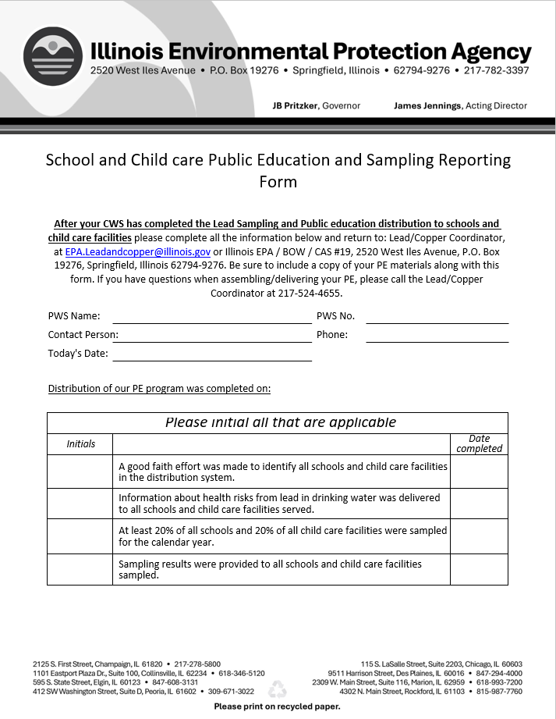

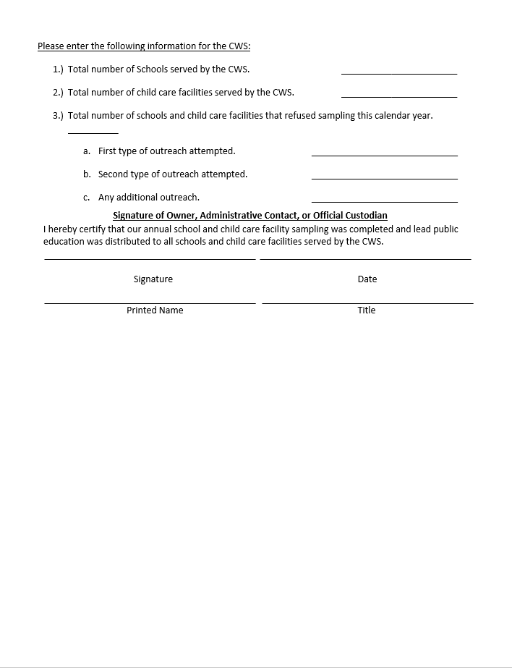

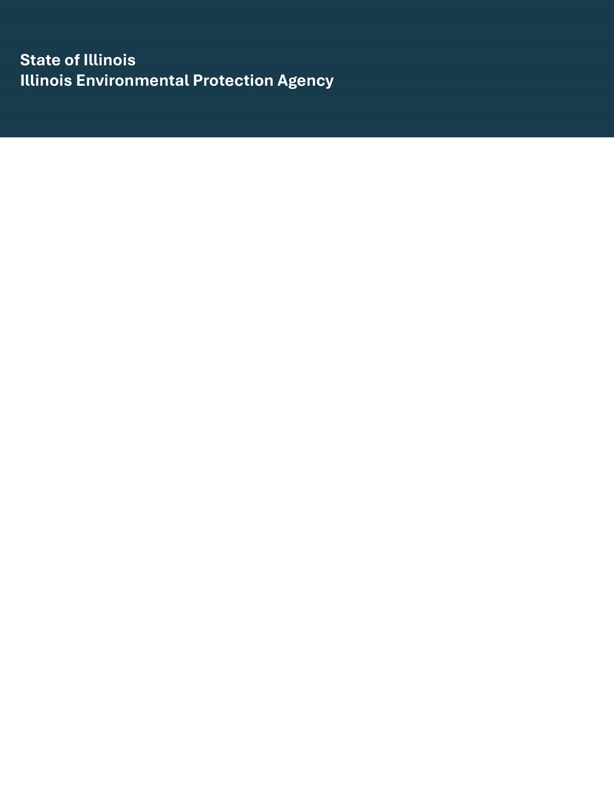
Monitoring for Lead in Schools and Child Care Facilities
October 2025

